School Hours
Monday, Tuesday, Wednesday, and Thursday 9am- 2pm
Wednesday Evening 5pm – 8pm

School Holidays 2022-2023:
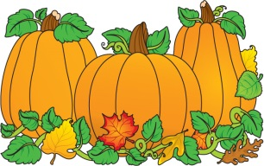
First Day of Classes: Sept.6th
Fall Break: Oct. 17th
Veterans’ Day Observance: Nov. 7-8
Thanksgiving Holiday: Nov. 23 - 27
Winter Break: Dec. 22 - Jan. 9
Martin Luther King, Jr. Day: Jan. 16
Presidents' Day: Feb. 20
Spring Break: April 9 – 15
Graduation: TBD
Last Day of Classes: May 25

