

School Holidays 2020-2021:

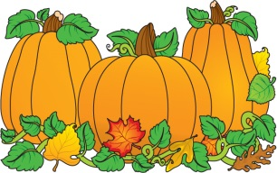First Day of Classes: Sept.1

Fall Break: Oct. 8-13

Thanksgiving Holiday: Nov. 23-27

At Home/Virtual Learning: Dec. 13-17

Winter Break: Dec. 21 - Jan. 5

Martin Luther King, Jr. Day: Jan. 18

Presidents' Day: Feb. 15

 Spring Break: April 5 – April 9

Graduation: TBA

Last Day of Classes: May 27

